**Lab1-Assignment**

**Lab 1.3--🡪 Create an Amazon EC2 Instance(name- LnDJavaLab1) and run a tomcat with Sample Hello World application.**

Sol….

**Step1- Login to your console and select services🡪 EC2.**

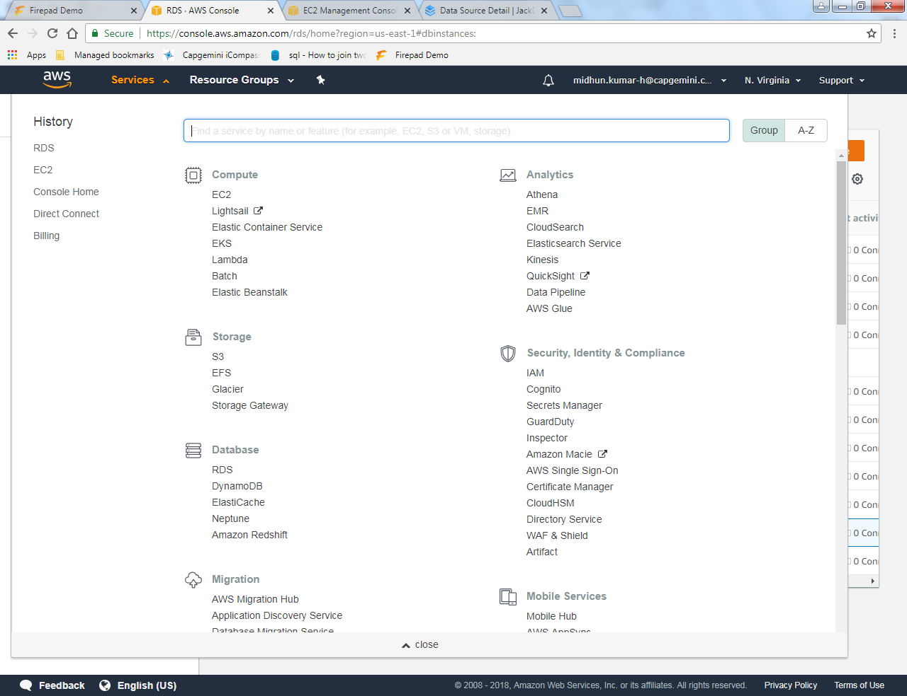

**Step2- In EC2, select Launch Instance.**

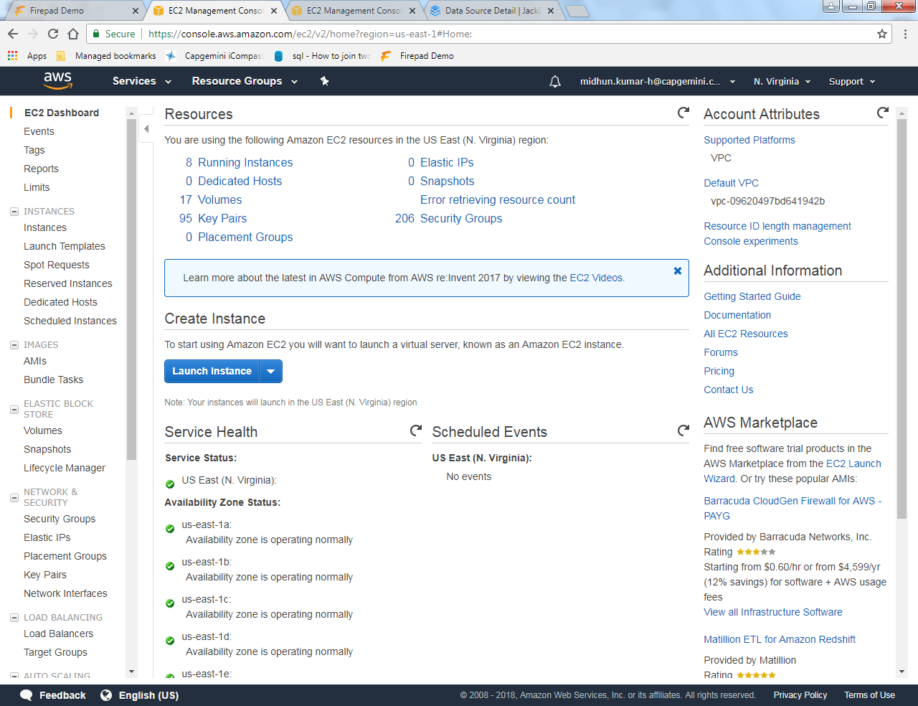

**Step3- Select Free tier only in the left panel and select Amazon Linux AMI-2018(2nd AMI).**

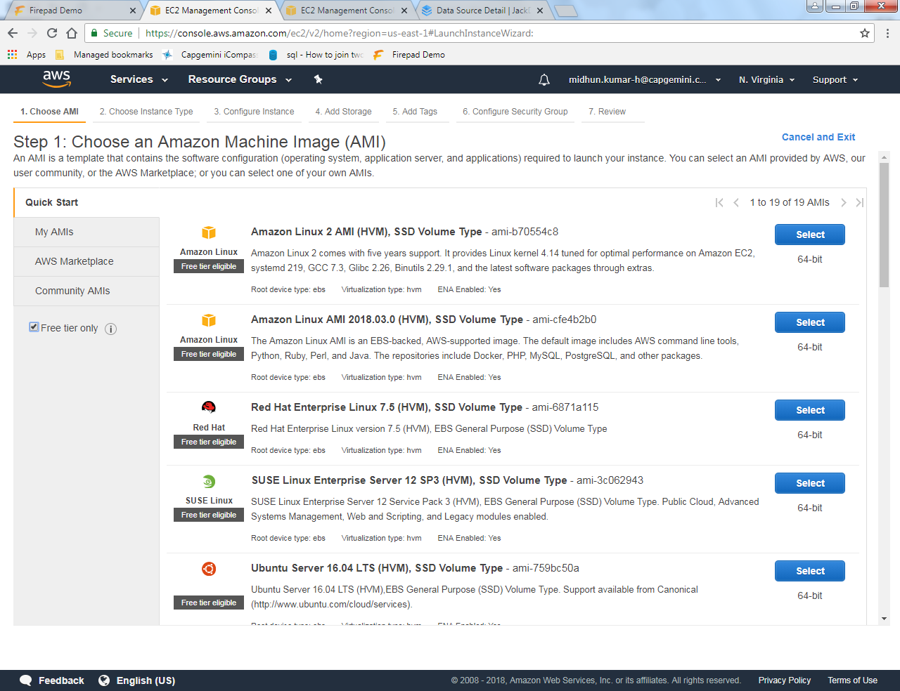

**Step 4 : Choose an instance type – t2.micro and click on next**

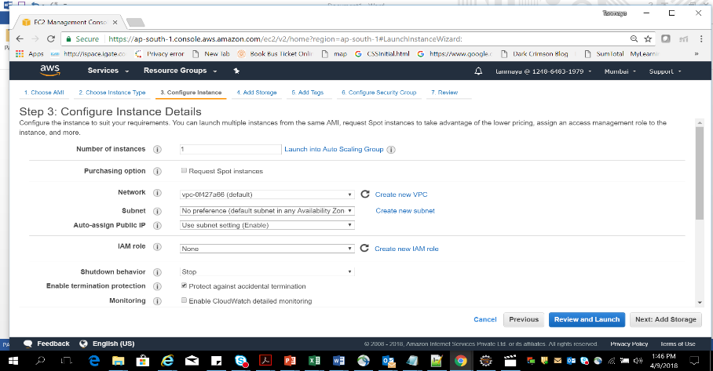

**Step 5: Click on Next: Add Storage.**

**Step 6: Choose Storage type🡪Magnetic and choose Next : Add tags button**

**Step 7: Add the different tags (Key value) .**

**Step 8: Now click on Next : Configure Security groups . Choose the New security**

**Group and provide the details i.e. name, description etc. Keep the name as - LnDJavaLab1.**

**Step 9: Add different rules as per the traffic you want to access your account(optional)**

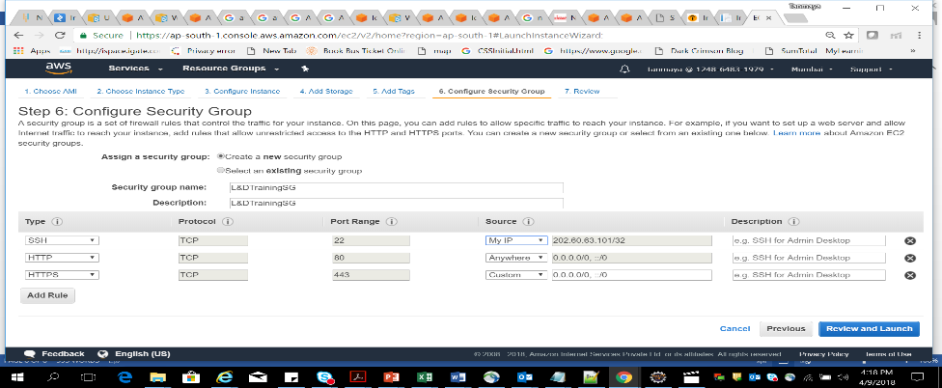

**Step 10 : Click on Review and Launch button**

**Step 11 : Click on Launch button**

**Step 12 : Provide a key pair name and Download Key Pair into “d:\keypairs\” drive.**

**After that launch instance button.**

**Step 13 : Now see the instances from EC2 dashboard and see the instance .**

**Step 14 : Click on the instance to see the details**

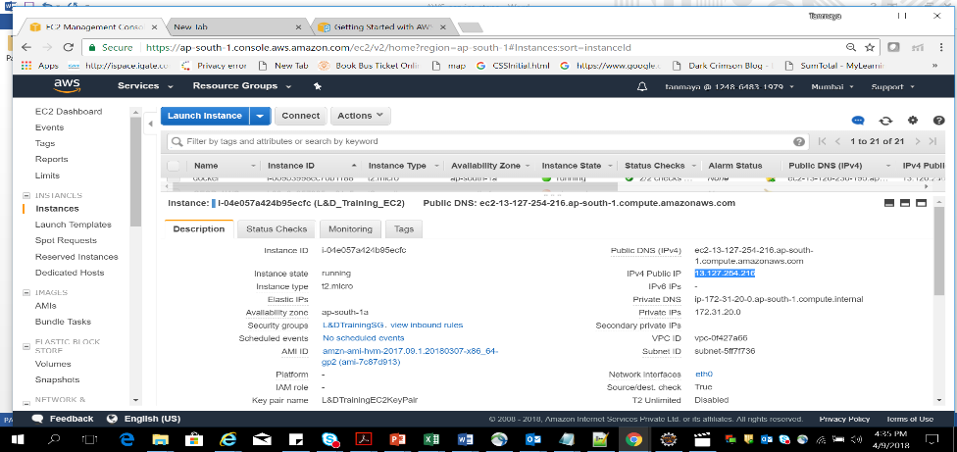

**Step 15: Download the 64bit of putty.exe and puttygen.exe**

**Step 16: Right click on putty.exe file, puttygen.exe and save it to a drive**

**Step 17: Now run your puttygen and then click on load button to load the .pem file**

**Step 18: Then it will be successfully imported**

**Step 19: Now click on ok and click on save private key button.**

**Step 20: Click on yes button**

**Step 21: Then choose the .pem file and change the ext to .ppk . Click on save button.**

**Step 22: Now Open Putty.exe file.**

**Step 23: Type the host name: ec2-user@<<13.127.254.216>>.**

**Step 24: Expand SSH section on left pane and select the “Auth “ submenu.**

**Step 25: And browse the private key .ppk**

**Step 26: Now click on session on left pane**

**Step 27: copy the host name to saved sessions .**

**Step 28 : Then click on save button on right**

**Step 29: Now again select your session in saved session text area , click on Load and then click on open button**

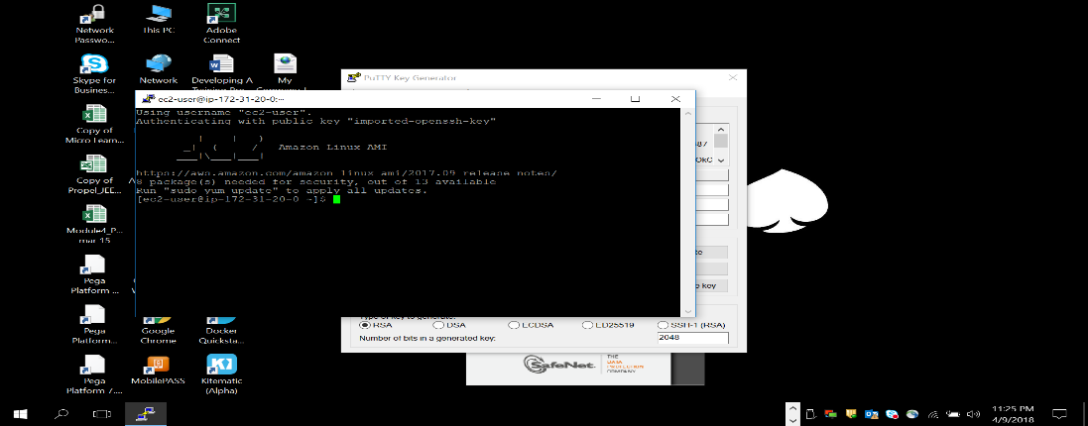

**Step 30: Type the command “Sudo /usr/sbin/alternatives –config javac“ <<enter>>**

**Step 31: Type “java -version” command <<enter>>**

**Step 32: Type command “yum list tomcat*” <<enter>>**

**Step 33: Type command “sudo yum install tomcat8” <<enter>>**

**Step 34: Type “y” <<enter>>**

**Step 35: Type command “sudo yum install httpd” <<enter>>**

**Step 36: Type “y” <<enter>>**

**Step 37: Type command “sudo yum install tomcat8-admin-webapps” <<enter>>**

**Step 38: say “y” and enter**

**Step 39: Type command “sudo yum install tomcat8-webapps” <<enter>>**

**Step 40: say “y” and enter**

**Step 41: Type command “sudo service tomcat8 start” <<enter>>**

**Step 42: Go to EC2 instance and open the port 8080**

**Step 43: Copy the public DNS of your instance .**

**Step 44: Open the browser and Type the URL : - <Public dns>: ec2-52-207-216-30.compute-1.amazonaws.com**

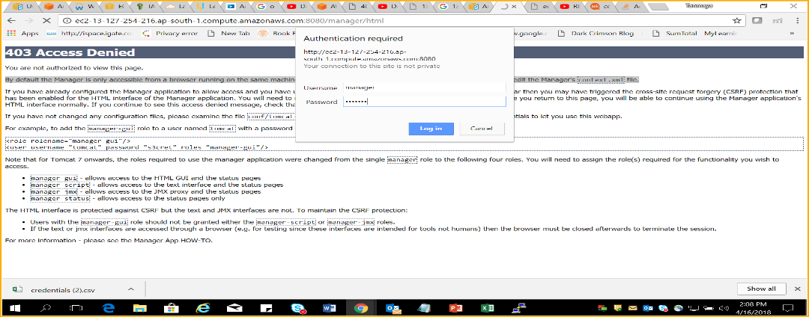

If this Authentication Prompt is not shown and you get 403 access Denied error Follow below steps **otherwise directly jump to Step 55 .**

**Step 45: Open the putty and write the command cd /usr/share/tomcat8**

**Step 46: Type command “Cd conf” <<enter>>**

**Step 47: Type command “ls” <<enter>>**

**Step 48: Type command “cd Catalina” <<enter>>**

**Step 49: Type command “cd localhost” <<enter>>**

**Step 50: Type command “ls” <<enter>>. If there is no file i.e. manager.xml available in localhost then create it**

**Step 51: Type command “sudo vi manager.xml” <<enter>>**

**Step 52: Type the below element in that file**

**<Context privileged="true" antiResourceLocking="false"**

**docBase="${catalina.home}/webapps/manager">**

**<Valve className="org.apache.catalina.valves.RemoteAddrValve" allow="^.*$" />**

**</Context>**

**Step 53: Press Escape key and type “ :wq!” (save and exit)**

**Step 54: Type command “sudo service tomcat8 restart” <<enter>>.**

**Step 55: Now go back to tomcat8 location**

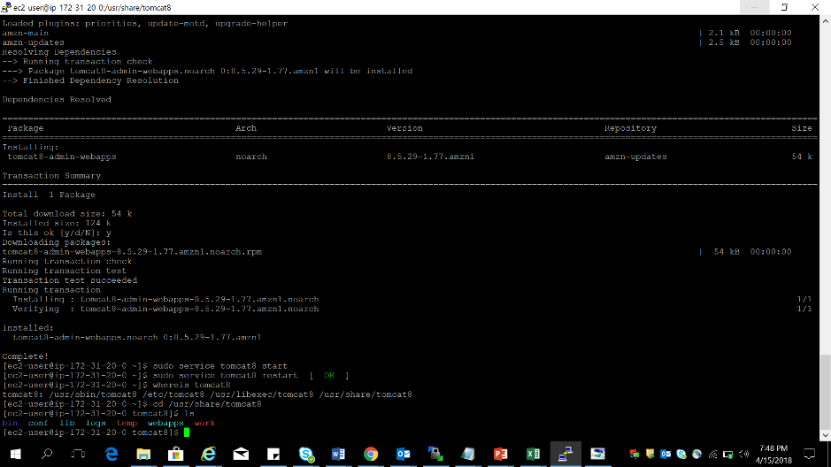

**Step 56: Type command “cd conf” <<enter>>**

**Step 57: Type command “ls” <<enter>>**

**Step 58: Type command “sudo vi tomcat-users.xml” <<enter>>(edit this file)**

**Step 59: Press “o” key from keyboard and enter few elements**

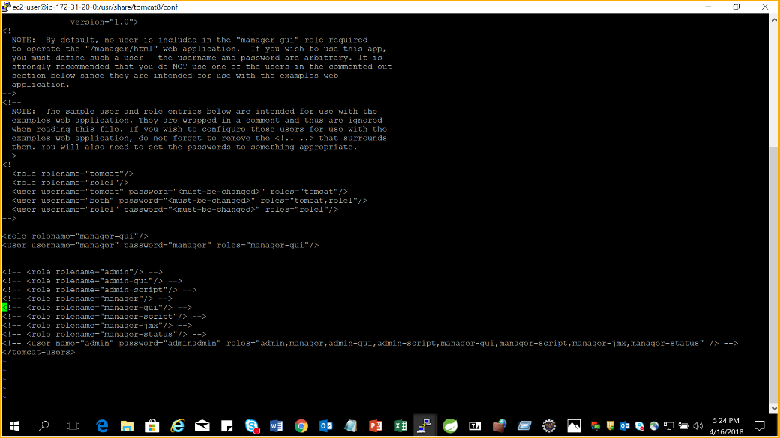

**Step 60: Now save this file.**

**Step 61: Go to the browser and enter the URL.**

**Step 62: Enter user – manager and password - manager <<login>>**

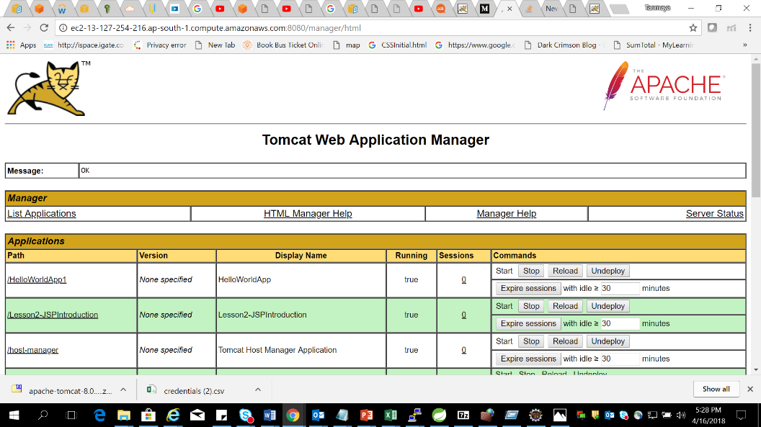

**Step 63: Now develop a Helloworld application in your system by using Java7 and tomcat8 .Run it and test your app.**

**Step 64: export war file to a location.**

**Step 65: scroll down the browser and click on deploy war file button.**

**Step 66: Now click on the application link and see the output .**

************************************The END******************************************